Bahria University,

Karachi Campus



LAB EXPERIMENT NO.

**6**

LIST OF TASKS

|  |  |
| --- | --- |
| TASK NO | OBJECTIVE |
| 1 | Create Department table based on the given design. |
| 2 | Create Employee table based on the following design: |
| 3 | Modify Employee table and add three more columns: |
| 4 | Drop Column loc from Department table. |
| 5 | Delete all record from Employee table. |
| 6 | Drop Department Table. |
| 7 | Create database Authorization Add a column ‘Address’ in Starsin table in database Authorization. CREATE TABLE StarsIn ( movieTitle char(30), movieYear int,starName char(30) ). |
| 8 | Solve the Queries given below according to the following tables given below:  a) Apply Not Null Constraint on all columns .  b) Apply primary key constraint in OrderID and customer ID.  c) Apply foreign key constraint on Customer _ID in Order table.  d) Apply check constraint on city (allow Karachi, Islamabad, Lahore only).  e) Set the default value of City as ‘Karachi’.  f) Add CNIC column in Customer table with unique constraint. |
| 9 | Create the following tables given in diagram with constraints (PK-FK relationship). |
|  |  |
|  | . |
|  |  |

Submitted On:

Date: 19/04/2022

**Task No. 1: Create Department table based on the given design.**

**Solution:**

create Table Department( deptno decimal(2,0) not null primary key, dname varchar(14), loc varchar(13) )

**Output:**

**Task No. 2: Create Employee table based on the following design:**

**Solution:**

create Table Employee( empno decimal(4,0) not null primary key, ename varchar(10) not null,

job varchar(9), mgr decimal(4,0) , hiredate date)

**Output:**

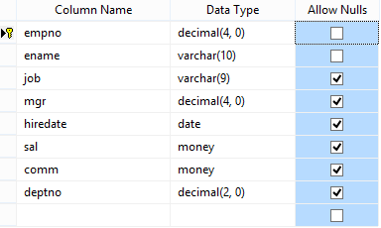**Task No. 3: Modify Employee table and add three more columns:**

**Solution:**

alter Table Employee add sal money, comm money, deptno decimal(2,0)

**Output:**

**Task No. 4: Drop Column loc from Department table.**

**Solution:**

alter Table Department drop column loc

**Output:**

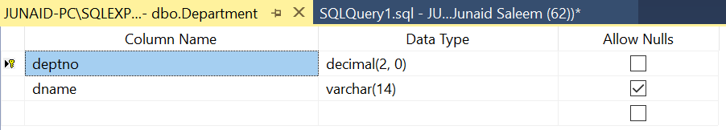

**Task No. 5: Delete all record from Employee table.**

**Solution:**

truncate table Employee

**Output:**

**Before Delete**

**After Delete**

**Task No. 6: Drop Department Table.**

**Solution:**

Drop Table Department ;

**Output:**

**Before After**

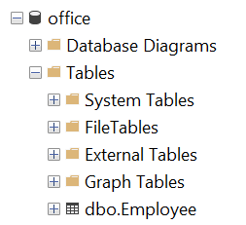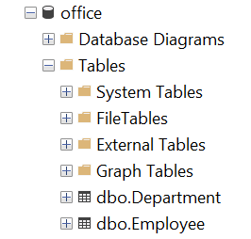

**Task No. 7: Create database Authorization Add a column ‘Address’ in Starsin table in database Authorization. CREATE TABLE StarsIn ( movieTitle char(30), movieYear int,starName char(30) );**

**Solution:**

create database [Authorization]

use [Authorization]

Create Table StarsIn ( movieTitle char(30), movieYear int, starName char(30) )

Alter Table StarsIn add Address varchar(30)

**Output:**

**Task No. 8: Solve the Queries given below according to the following tables given below:**

1. **Apply Not Null Constraint on all columns .**
2. **Apply primary key constraint in OrderID and customer ID.**
3. **Apply foreign key constraint on Customer _ID in Order table.**
4. **Apply check constraint on city (allow Karachi, Islamabad, Lahore only).**
5. **Set the default value of City as ‘Karachi’.**
6. **Add CNIC column in Customer table with unique constraint.**

**Solution:**

create table Table_Orders(

Order_ID int primary key not null,

Customer_ID int not null references Table_Customers(CustomerID),

Order_Details varchar(30) not null,

Order_Date datetime not null,

Required_Date datetime not null);

create table Table_Customers(

CustomerID int primary key not null,

FirstName varchar(100) not null,

LastName varchar(100) not null,

City varchar(255) not null default 'Karachi',

Address text not null,

Constraint CHK_Customers check (City in ('Karachi','Islamabad','Lahore')));

Alter Table Table_Customers Add CNIC char(15) unique not null;

**Output:**

**Task No. 9: Create the following tables given in diagram with constraints (PK-FK relationship).**

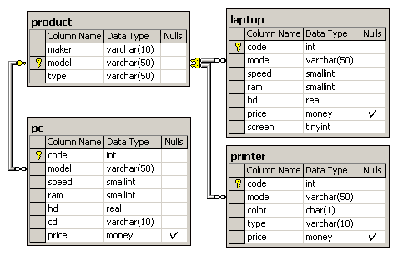

**Solution:**

|  |  |
| --- | --- |
| **Product:**  create table product(  maker varchar(10) not null,  model varchar(50) primary key not null,  type varchar(50) not null  ) | **Laptop:**  create table laptop(  code int primary key not null,  model varchar(50) not null references product(model),  speed smallint not null,  ram smallint not null,  hd real not null, price money,  screen tinyint not null ) |
| **PC:**  create table pc(  code int primary key not null,  model varchar(50) not null references product(model),  speed smallint not null,  ram smallint not null,  hd real not null,  cd varchar(10) not null,  price money ) | **Printer:**  create table printer(  code int primary key not null,  model varchar(50) not null references product(model),  color char(1) not null,  type varchar(10) not null,  price money  ) |

**Output:**

